**Project Design Phase-II**

**Technology Stack (Architecture & Stack)**

|  |  |
| --- | --- |
| Date | 14 October 2022 |
| Team ID | PNT2022TMID50005 |
| Project Name | News Tracker Application |
| Maximum Marks | 4 Marks |

**Technical Architecture:**

The Deliverable shall include the architectural diagram as below and the information as per the table1 & table 2

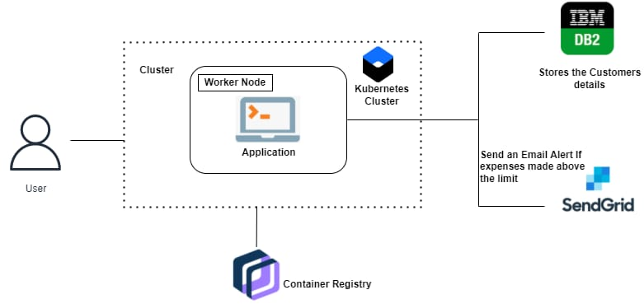

|  |  |  |
| --- | --- | --- |
|  |  |  |

**Table-1 :Components & Technologies:**

|  |  |  |  |
| --- | --- | --- | --- |
| **S.No** | **Component** | **Description** | **Technology** |
|  | User Interface | User interact with application using form, login, Request notification | Python FLASK, HTML, CSS |
|  | Registration | User register in the application to connect bank account | Python FLASK, HTML, CSS, IBM DB2 |
|  | Registration | Verification of user and their account details | Python FLASK, HTML, CSS, IBM DB2 |
|  | Notification of registration | Sends the notification to the user | Python FLASK, HTML, CSS, IBM DB2 |
|  | Tracking of news | News tracking by application | Python FLASK,IBM Db2 |
|  | Cloud Database | Database Service on Cloud | IBM DB2 |
|  | Kubernetes cluster | Run Containerized application | IBM Kubernetes |

**Table-2: Application Characteristics:**

| **S.No** | **Characteristics** | **Description** | **Technology** |
| --- | --- | --- | --- |
|  | Open-Source Frameworks | Docker is used for Open Source Framework | DOCKER |
|  | Scalable Architecture | It connected with Scalable Architecture | IBM DB2 |
|  | Availability | This application is anytime accessible | Python FLASK |

